In this report, I am summarizing the actions taken for completing the geospatial assignment. As the first step and as instructed, I tried to run both choropleth and bubble maps source codes available in the immersive analytics github repo. The following snapshot shows that I have successfully run both projects in my own machine.

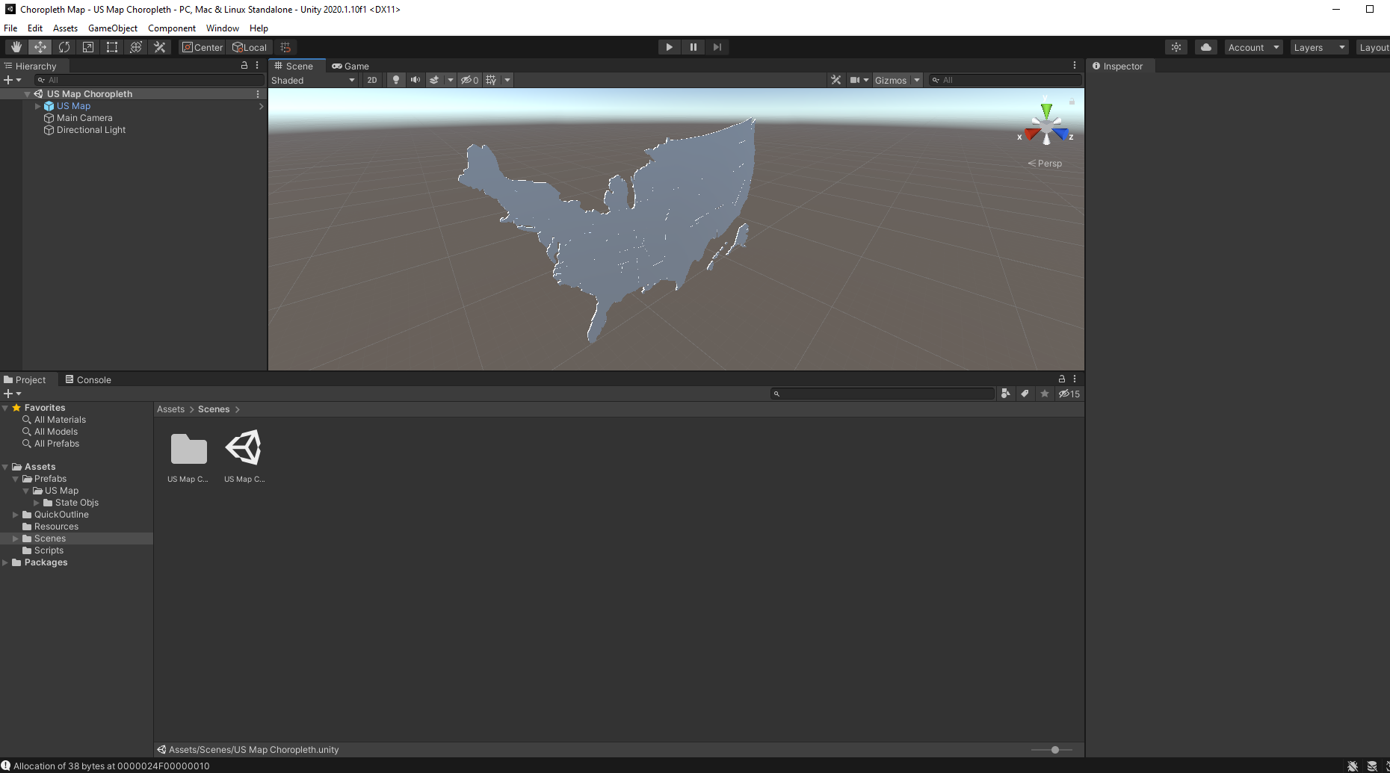

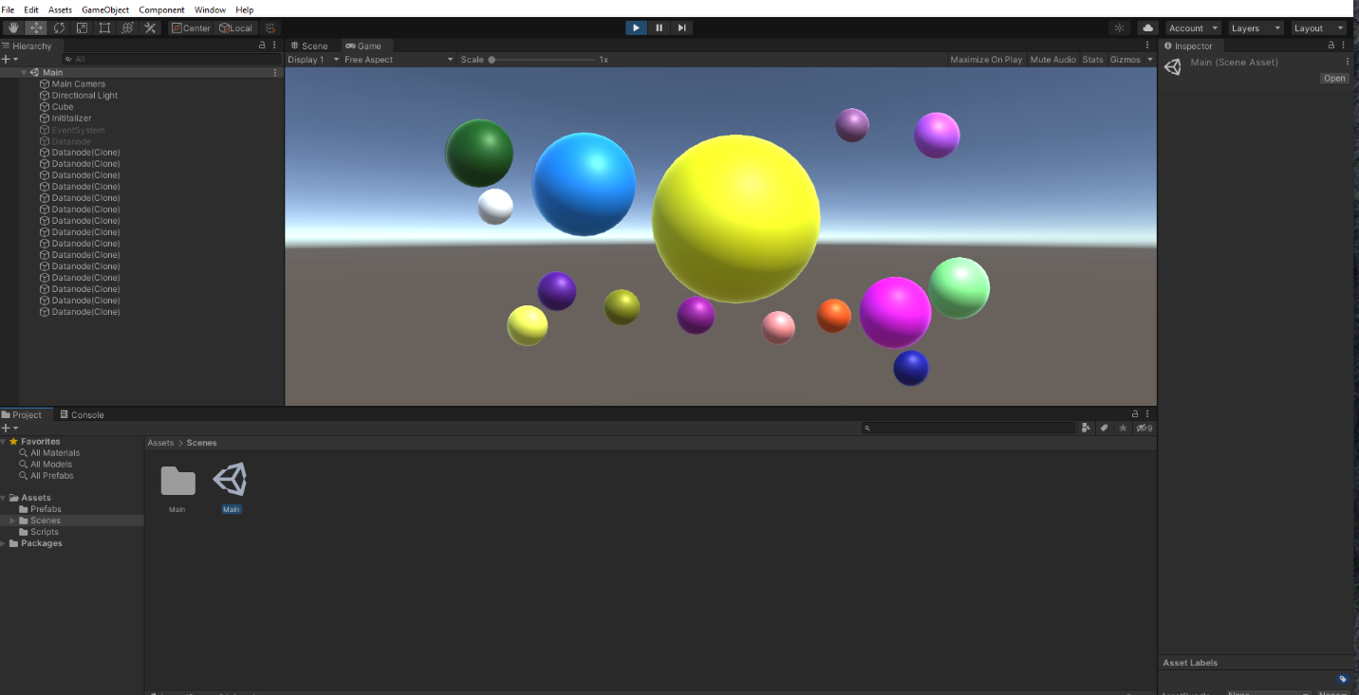

The dataset I used for this project is the number of Covid-19 cases per state in the last 7 days ending in October 25th. The dataset can be found [here](https://covid.cdc.gov/covid-data-tracker/#cases_casesinlast7days). Basically, I want to see the situation based on the accumulative number of Covid-19 cases in the past 7 days in different states. The color-coding guideline is provided here:

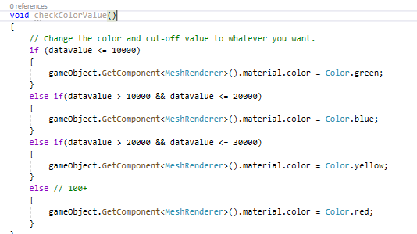

According to this guideline, the US map looks like this:

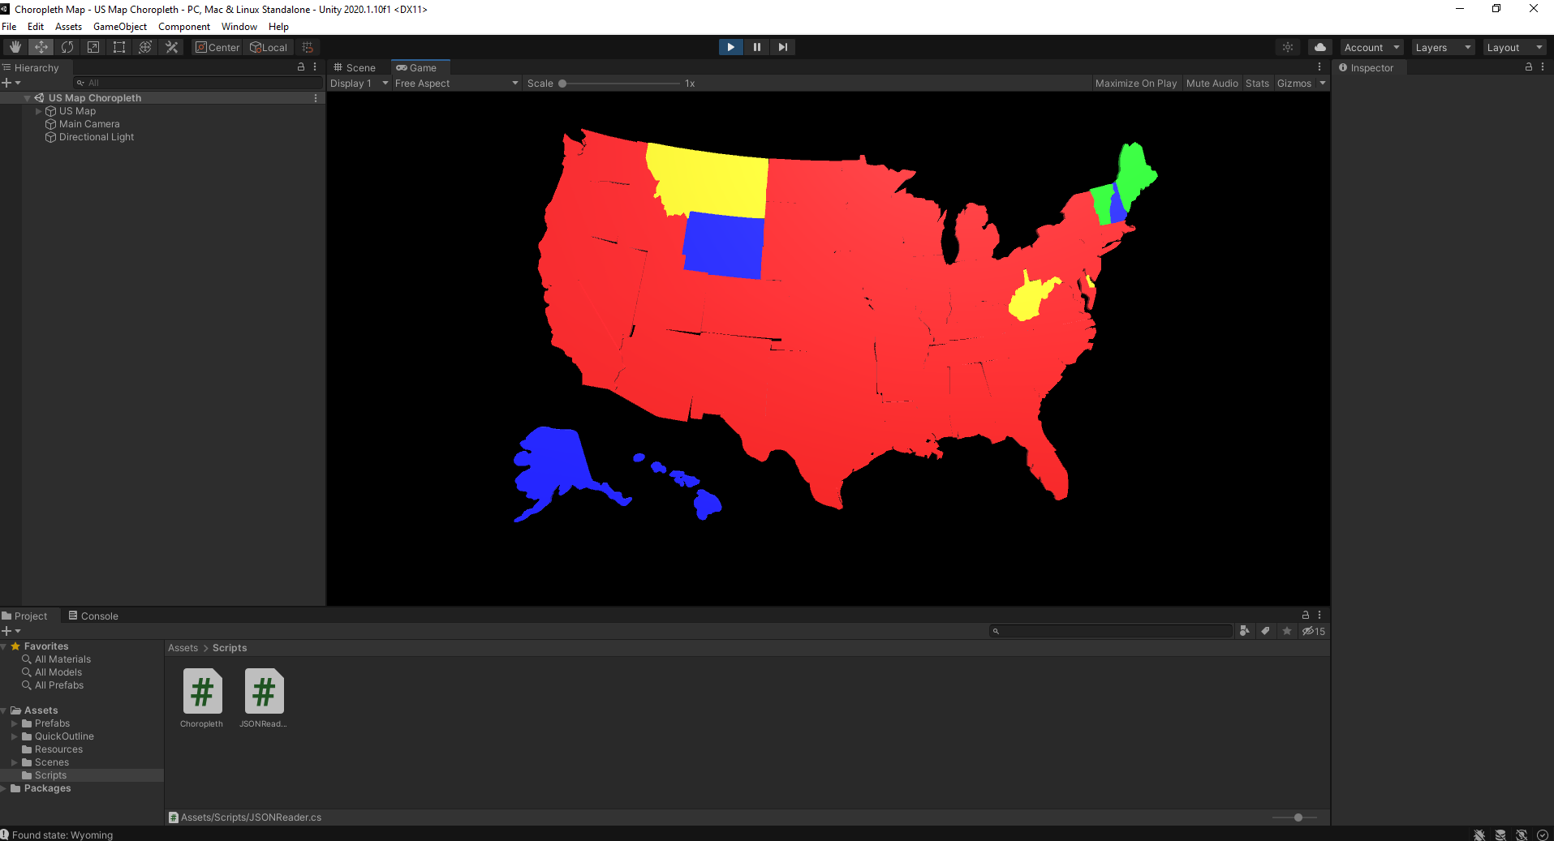

As it can be seen, pretty much all states are experiencing a huge spike in the number of Covid-19 cases in the past 7 days. The interesting part is West Virginia, where it is the only states surrounded by red states which has managed to keep its number of cases relatively lower. Wyoming also seems to be in control in terms of the number of cases. Alaska is also another state that has been relatively successful in keeping the number of cases low.